**Exercise 1**

**Build IoT System with ThingsBoard**

The goal of this tutorial is to demonstrate the basic usage of the most popular ThingsBoard features. You will learn how to:

* Connect devices to ThingsBoard.
* Push data from devices to ThingsBoard.
* Build real-time end-user dashboards.
* Define thresholds and trigger alarms.
* Set up push notifications about new alarms over email, SMS, or other systems.

**Step 1: ThingsBoard Account Creation**

1. Go to the ThingsBoard Cloud website < https://thingsboard.cloud/signup>
2. Sign up for your 1-month trial ThingsBoard account using your email.

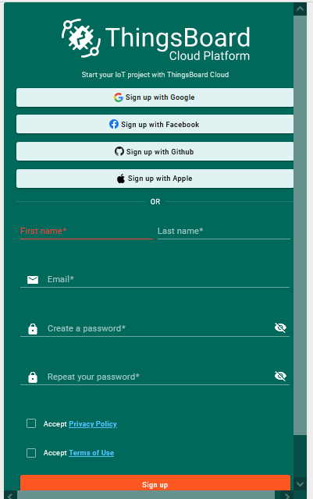

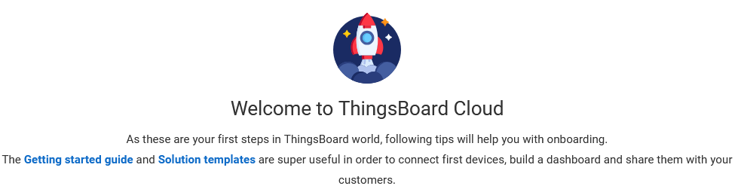

**Step 2: Provision/Add a Device:**

Let’s add a device that will transmit the following data to the ThingsBoard platform: the device’s name and temperature readings as telemetry.

To add a new device, follow these steps:

1. Login to your ThingsBoard account instance
2. Click “Entities 🡪 Devices,” or directly click “Add device.”

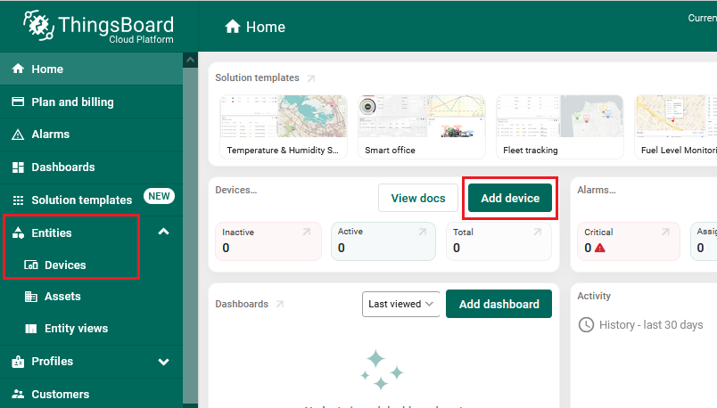

1. Click on the "+" icon located in the top right corner of the table, and then select "Add new device".

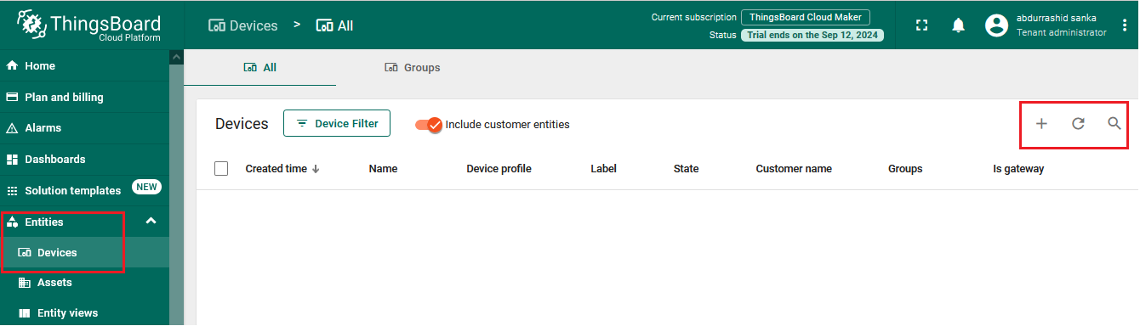

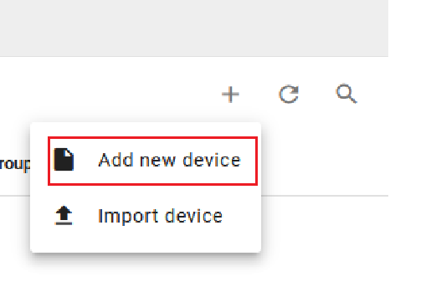

1. Enter a name for your device, for example, "**Temp-sensor1**". No other changes are required at this time. Click "**Add**" to add the device.

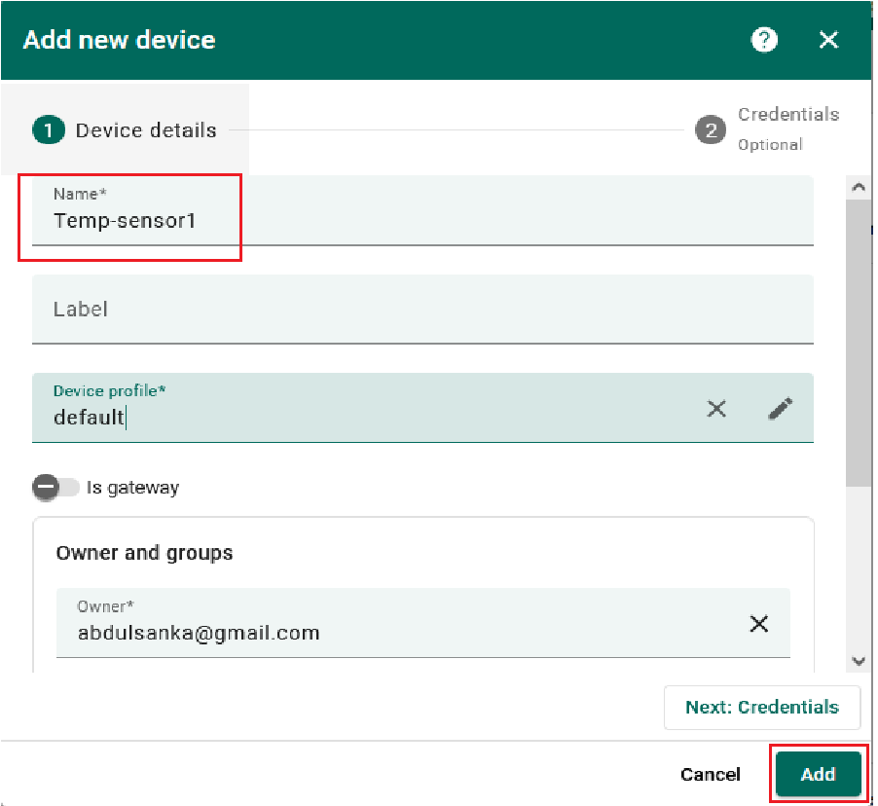

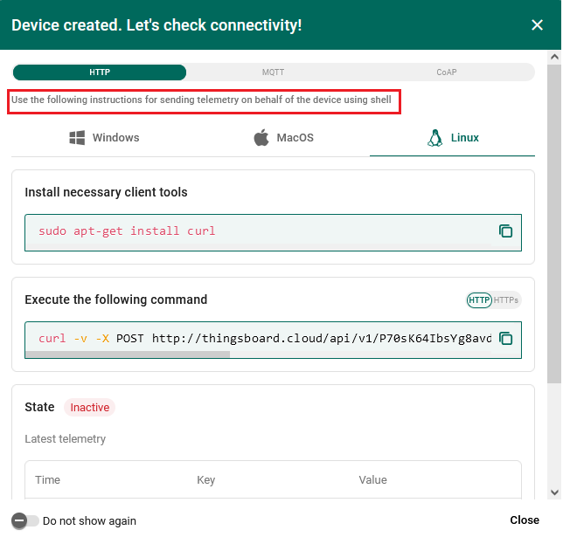

1. Now your device should be listed first, as the table automatically sorts devices based on their creation time by default.

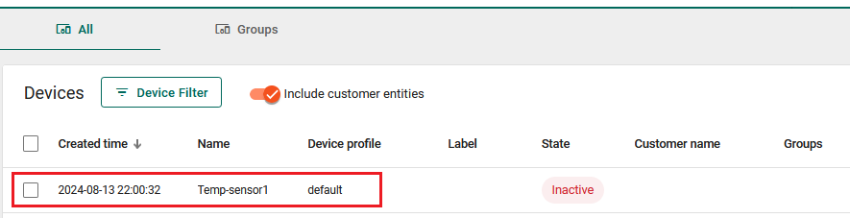

1. Create a group of your device.

From the Devices menu, click “**Groups**”.

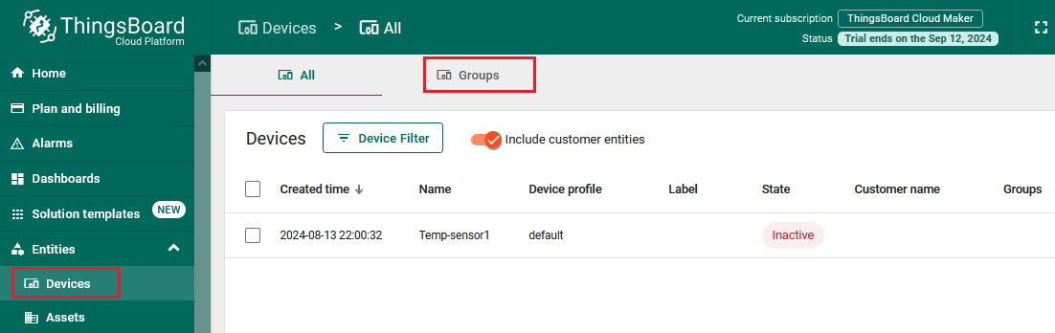

Click Add entity “+”

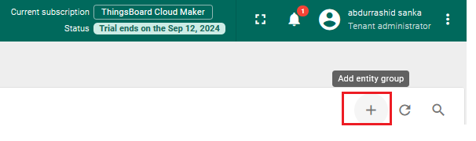

Enter the name and description of the group.

Click Add, the group will be created and displayed on the Groups page.

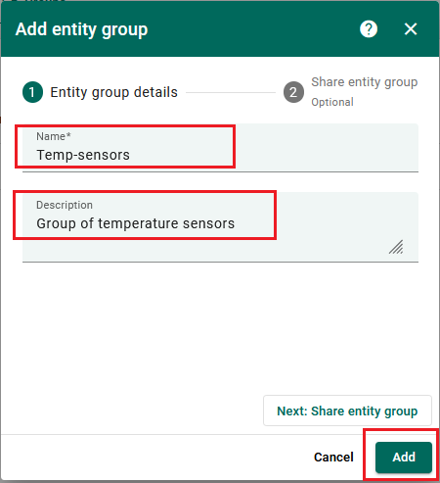

1. Add your device to the group.

Click “Entities 🡪 Devices”, then click your device

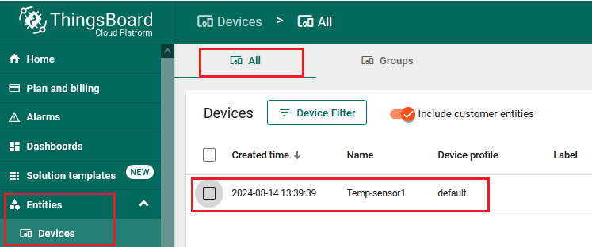

Select “**Manage owner and groups**”.

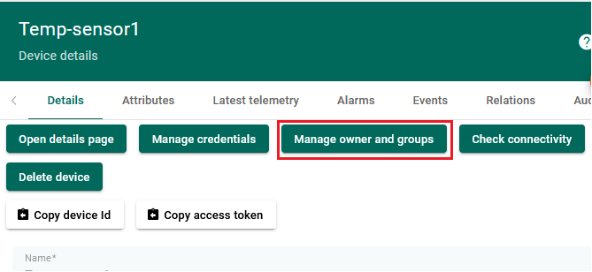

Select and add group (**Temp-sensors**),

Click **Update**

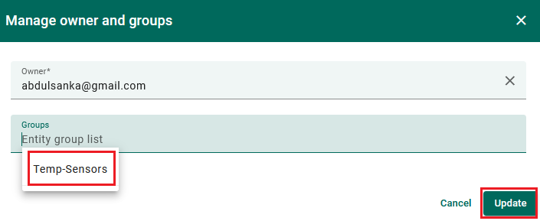

The device will be added to the group.

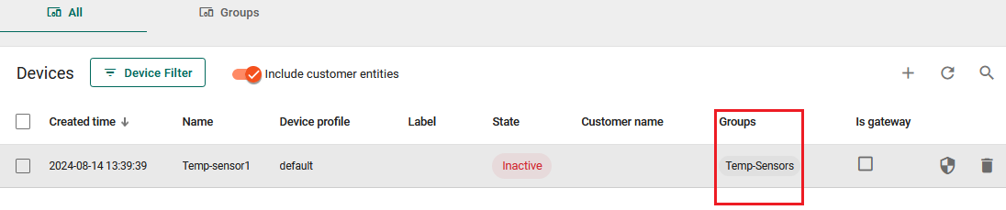

1. **Another way to create a device in a group.**

From “Entities 🡪 Devices,” select “Groups,” and a new page will open.

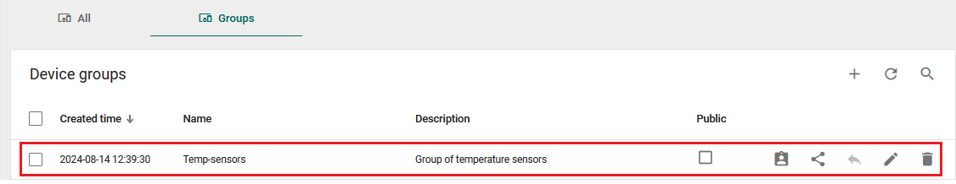

Select “**+**” to add the device.

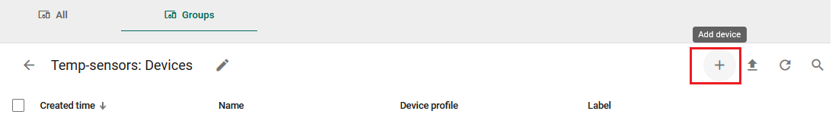

Enter the name of your device and click “**Add**”.

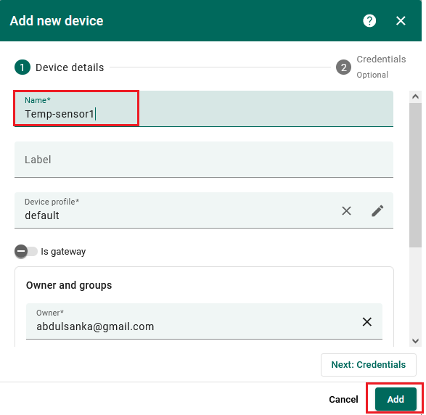

**Step 3: Create a Dashboard to Display Sensor Data**

A dashboard in ThingsBoard allows users to visualize and monitor data collected from IoT devices.

Let’s create a dashboard and add three widgets to it to display a list of entities and their latest values.

1. Open the “Dashboards” page. Select “Groups”. Click on the "+" icon in the top right corner to create an entity group.

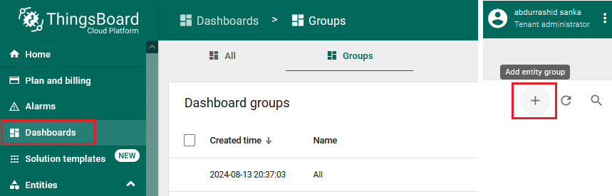

1. Enter a name for the entity group, "My_Records". Click "Add".

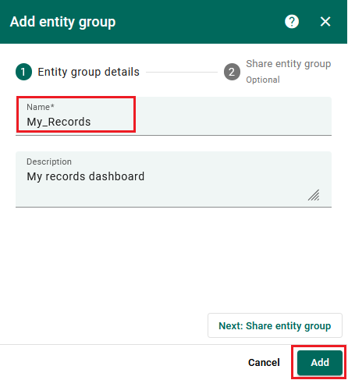

1. Click the dashboard group. Click on the "+" icon in the top right corner to create a new dashboard. Enter a name for the dashboard “My_Temp_Record”. Click “Add”.

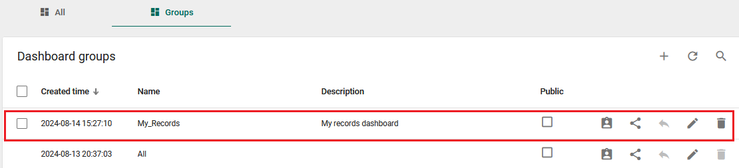

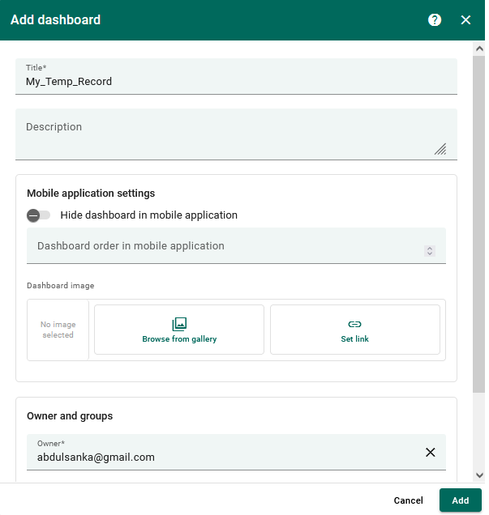

1. Enter edit mode. Click on the “Add new widget” button and choose a widget.

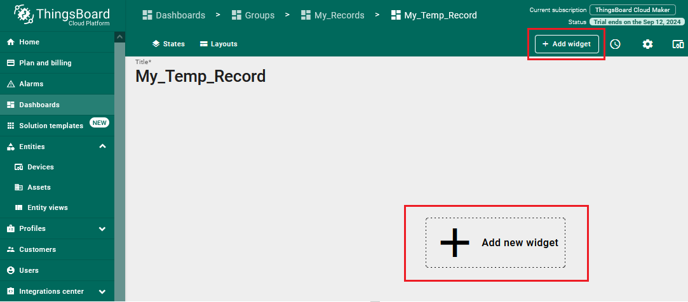

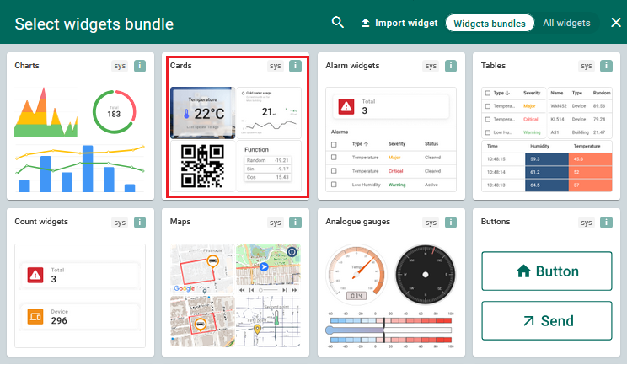

1. Set the Data source for the widget. Choose the “Device” that you want to link to. Choose the “Data key” of the device.
2. Click "Add." Adjust the widget's size or location to make it beautiful.

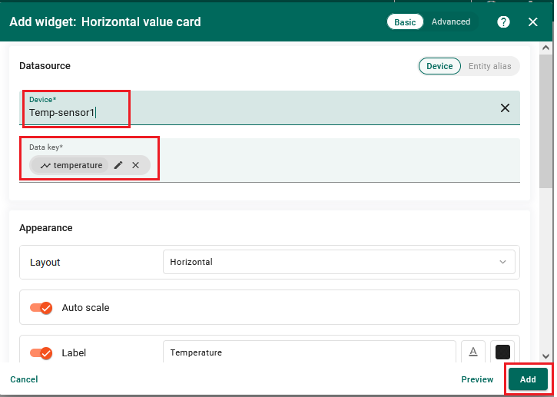

1. Finally, click "**Save**" in the top right corner of the dashboard to save the changes. You will then enter the edit mode again.
2. Repeat the above steps devices to add two more devices and Widgets.

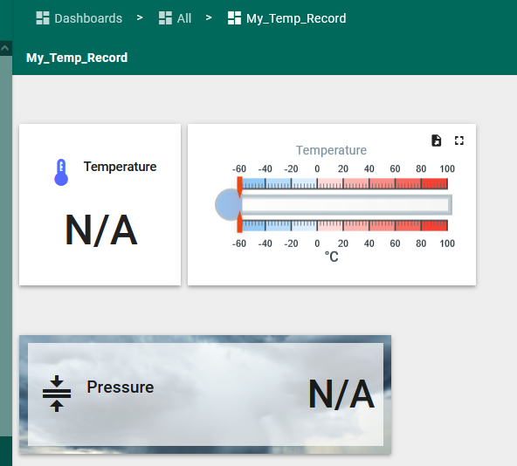

**Step 4: Simulate Sensor Reading Update on Dashboard**

Now let us try simulating the sensor device reading update.

1. From devices, select a device, then Attributes. Change Client attributes to “Shared attributes”.

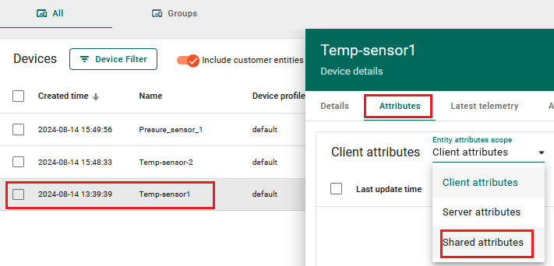

1. Click “+” to add a new attribute, enter the key (temp1), and give the temp value e.g., 15

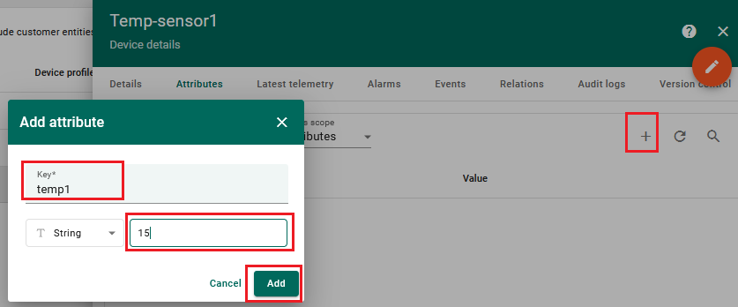

1. Open your dashboard and edit the widget by changing the “Data key” to the desired shared attribute (e.g. temp1). Click Apply.

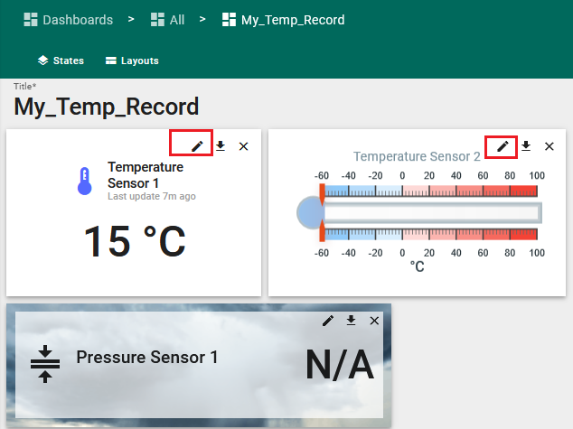

**PART 2: Connecting the Sensor with ThingsBoard**

**Step 1: Prepare your sensor.**

In this exercise, we will use Jetson AGX as our sensor. Follow the Jetson setup guide to set up the board and ensure it is connected to the internet and the terminal is working.

**Step 2: Check connectivity**

The most important task in IoT is the connectivity. Now we should check how to connect the board with the Things board. We should see the commands to be used for updating the records.

1. Under devices, click on the device (say temp-sensor1) and also click the “check connectivity” button. A new Windows will open.

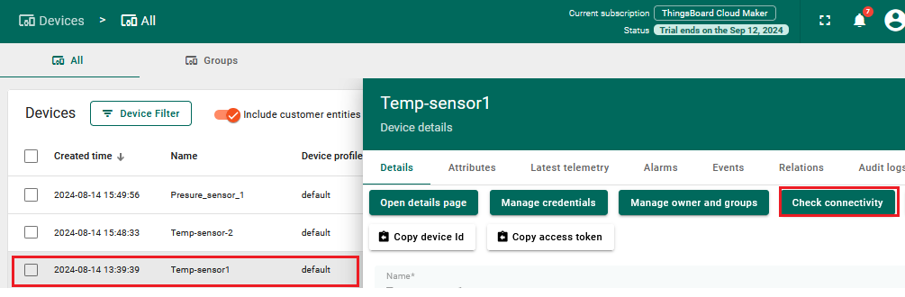

1. The Window that opens shows the various commands for sending data from the device to Things based on different protocols and operating systems. Navigate each setting and observe the commands.

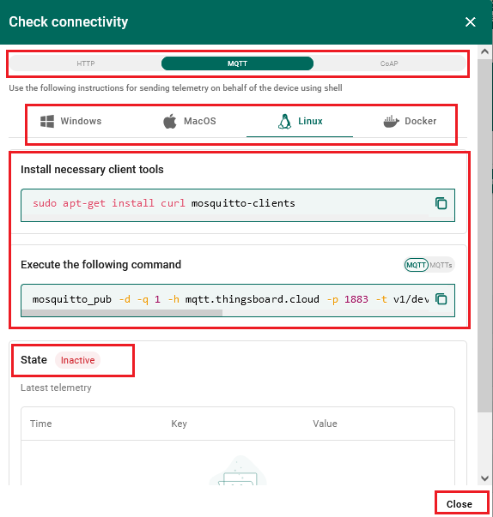

**Step 3: Update record**

Here, we will send the sensor readings from the Jetson to the ThingsBoard.

1. Open the terminal on the Jetson board. Install software tools such as Curl (Starting Windows 10 b17063, cURL is available by default) The desired tool will be shown in the connectivity Windows.

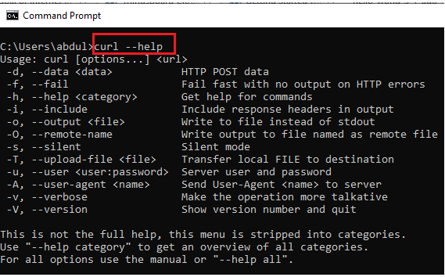

1. Open the device connectivity Windows as in step 2. Select your operating system and the desired protocol. Copy the command to the open Terminal on the Jetson board,
2. Change the device attribute on ThingsBoard to “**Client Attribute**”. Also change the data key of the device widget on the dashboard to the key in the command (e.g., Temperature). Run the command on the Terminal. Check ThingsBoard and confirm the update, the sensor will turn to Active.

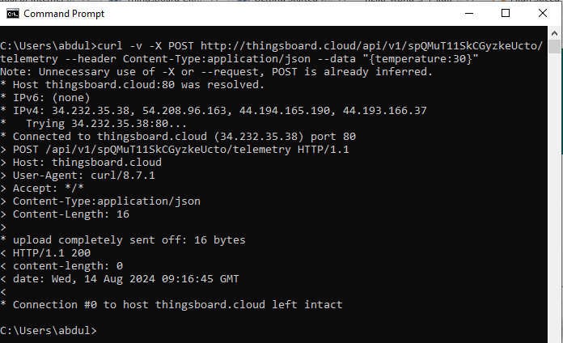

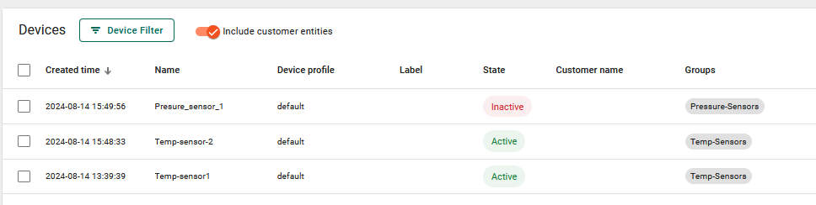

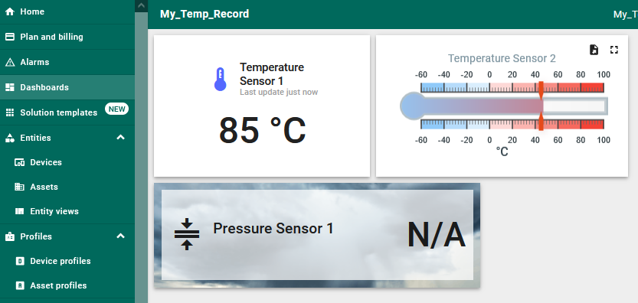

1. Try different both HTTP and MQTT protocols. Check the dashboard on ThingsBoard each time.
2. Follow the instructions to display your device in a visible format on the dashboard.